**Reference No:** C30…..

**Damage Report Date:** .11/12/13...

**Incidents must be reported immediately.**

Damage found in Container must not to be touched until pictures have been taken to effectively demonstrate to stake holders how damage could have occurred?

In Container Container No. LCL YAI00592

In Warehouse How was it damaged? Unpack during transit

Product

V212NT-G2 x5 S/N (21)0000222 ; (21)000224 ; (21)000225 ; (21)000228 ; (21)000229

VT20+ x1 S/N (21)083988

*Insert* Picture:

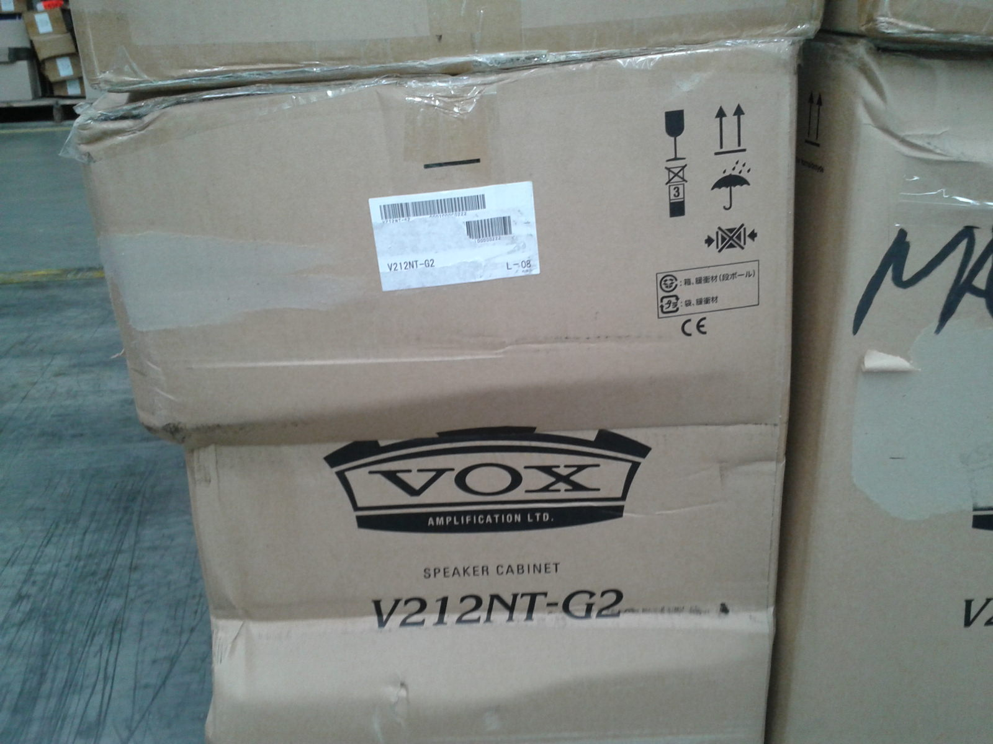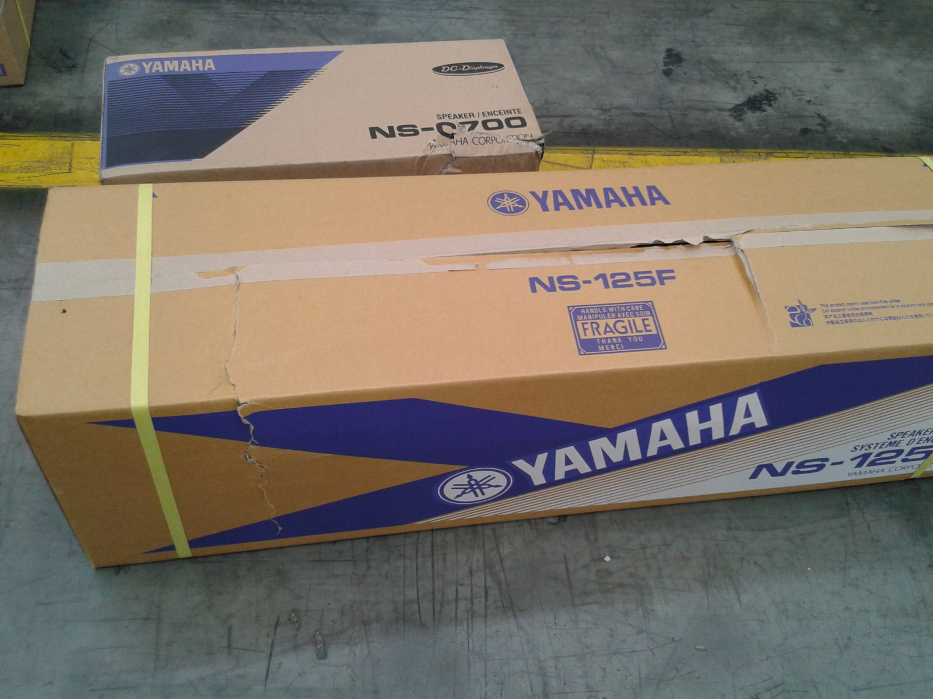

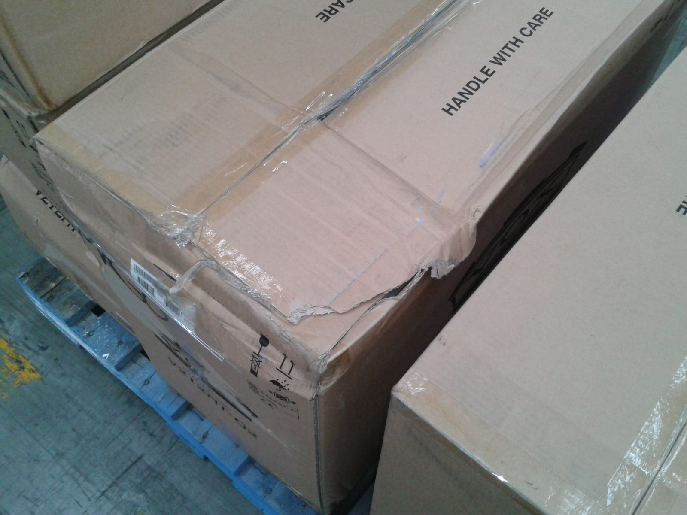

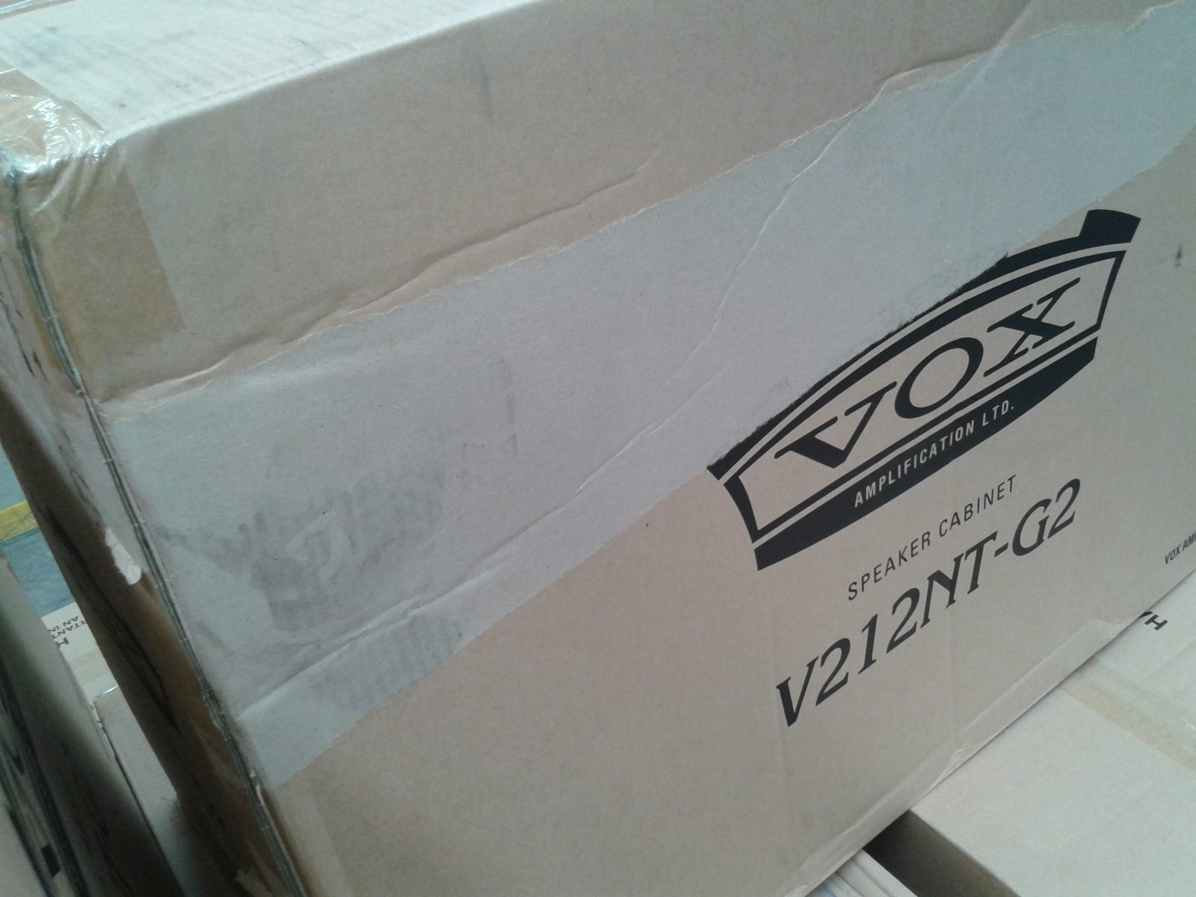

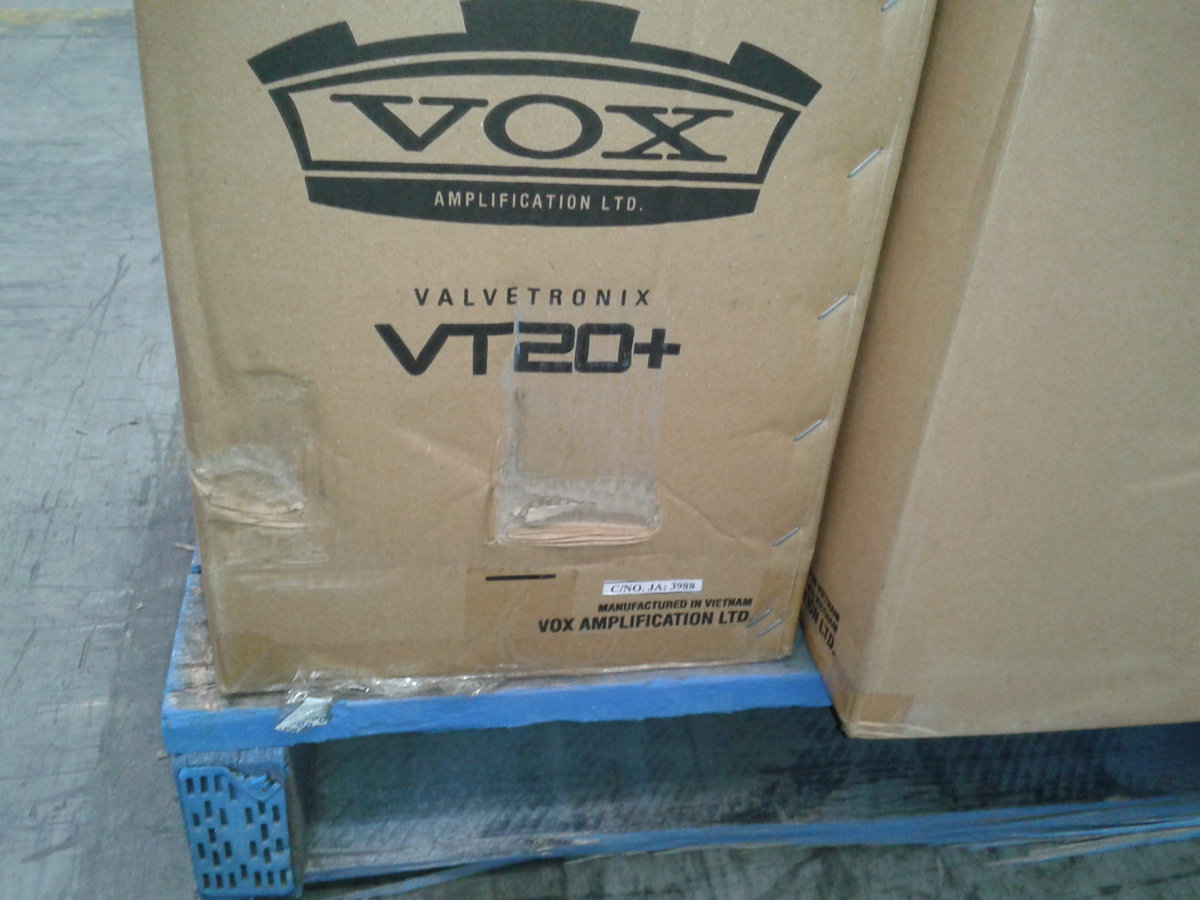

Reported by…Frank V…………………………………….